Day 5 – Phase 5: Scripting Automation, Redirection & FDs

**• Set an environment variable for sensor type.**

**• Write scripts/sensor_script.py to simulate data logging (timestamps + random values).**

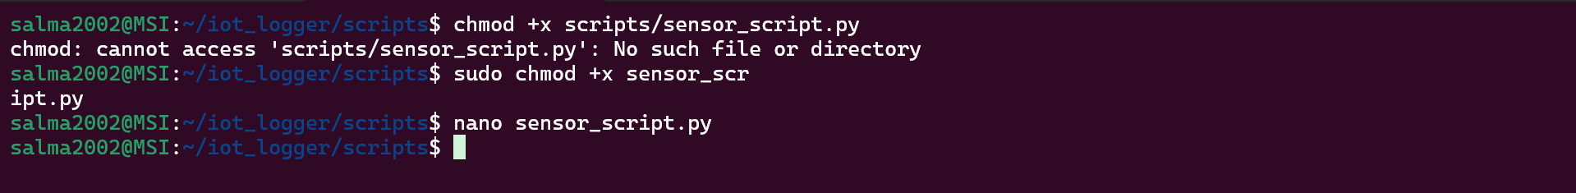

**• Redirect script output to logs/temperature.log while running as a background process.**

**• Find the PID of the process, inspect file descriptors in /proc//fd.**



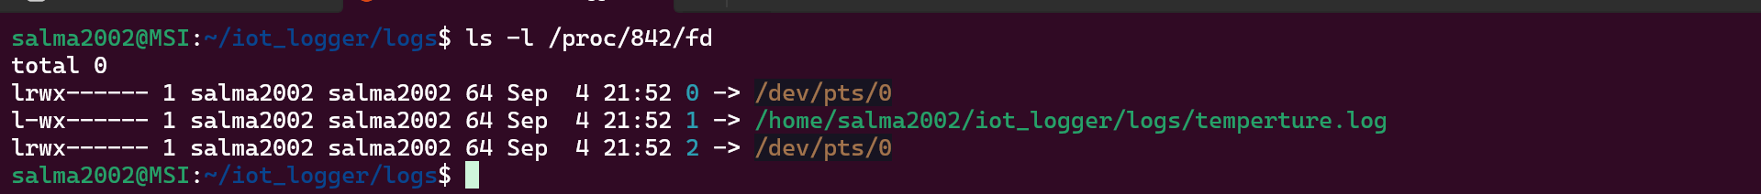

**• Filter log data into another file.**

**• Use wildcards to copy logs to data/.**

**• Clear variable when done.**

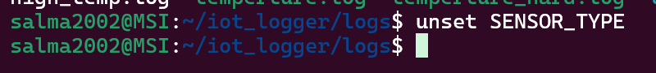

**Challenge – Pipes & FD inspection :**

**• Run a pipeline (e.g., ls -l | grep .py).**



**• While it’s running, inspect the FDs in /proc//fd.**

• Hint: To give yourself time, put a sleep in one command of the pipeline so the process stays alive long enough for inspection.

**Open-Ended Questions:**

**• What’s the difference between ' ' and " " in shell?**

* ' ' → literal, no variable/command expansion.

echo 'Hello $USER' 🡪 Hello $USER

* " " → expands variables/commands.

echo "Hello $USER" 🡪 Hello salma2002

**• Explain [ -f filename ] vs [ -d dirname ].**

[ -f file ] → true if file exists and is a regular file.

[ -d dir ] → true if path exists and is a directory.

**• Explain stdout/stderr redirection, appending vs overwrite. How can you confirm redirection using file descriptors?**

**What are stdout and stderr?**

* In Linux, everything is a file, even input/output.
* A process has 3 default file descriptors (FDs):
  + 0 = stdin (keyboard input)
  + 1 = stdout (normal output, like results of ls)
  + 2 = stderr (error messages, like “No such file or directory”)

**Redirection**

* > → send stream to a file (overwrite).
* >> → send stream to a file (append).
* By default, > means **stdout (1)**.